Customer Support Ticket Intelligence using Salesforce & Agentforce

Phase 1: Requirement Analysis & Planning

Project Overview
The project aims to develop an intelligent customer support ticket management system using Salesforce and Agentforce. The system automates the process of creating, analyzing, prioritizing, assigning, and monitoring customer support tickets.
The solution is designed to reduce manual effort, improve response time, ensure critical issues receive appropriate attention, and provide managers with better visibility into ticket status and team workload.

1: Understanding Business Requirements

Objective
The first phase focuses on understanding how customer support teams currently handle large volumes of service requests and identifying problems in the existing manual process.

Key Problems Identified
- Large number of customer support tickets.
- Manual ticket prioritization.
- Manual assignment of tickets to agents.
- Delays in handling urgent issues.
- Inconsistent priority classification.
- Uneven workload among support agents.

Business Requirements
The system should:
- Provide centralized ticket management.
- Classify tickets as High, Medium, or Low priority.
- Automatically assign tickets to support agents.
- Use Agentforce for ticket analysis.
- Create tasks for high-priority tickets.
- Provide ticket visibility to agents and managers.
- Support reports and dashboards.
- Provide secure, role-based access.

Automation Requirements
- Automatically analyze ticket descriptions.
- Automatically determine priority.
- Automatically assign tickets.
- Automatically create tasks for high-priority tickets.

Security Requirements
- Provide different access levels for agents and managers.
- Restrict sensitive fields where necessary.
- Ensure users can access appropriate ticket records.
- Protect customer and ticket information.

2: Defining Project Scope & Objectives

Project Scope
The project covers the development of a Salesforce-based ticket management system with AI-assisted analysis using Agentforce.

The system will:
- Create and manage customer support tickets.
- Analyze ticket descriptions.
- Classify ticket priority.
- Assign tickets to appropriate support agents.
- Create tasks for high-priority tickets.
- Track ticket status and workload.
- Provide basic visibility for agents and managers.
- Support monitoring through reports and dashboards.

Objectives
- Reduce response time for customer issues.
- Improve customer satisfaction through efficient ticket handling.
- Minimize manual effort through automation.
- Ensure critical issues receive appropriate attention.
- Improve team productivity and efficiency.
- Provide better visibility into support operations.

3: Gathering & Analyzing User Needs
The system is designed according to the needs of different users.

Users Involved

Support Agents
- Handle customer tickets.
- Need clear priority and assignment.
- Update ticket status and resolution.

Managers
- Monitor ticket status.
- Track team workload.
- Review priority and performance.
- Monitor delayed or risky tickets.

Customers
- Raise support issues.
- Expect timely responses and resolution.

Agentforce
- Analyze ticket descriptions.
- Support priority classification.
- Trigger configured actions and automation.

Key Functional Needs
The system should provide:
- Ticket creation and management.
- Automatic priority classification.
- Automatic ticket assignment.
- Task creation for high-priority tickets.
- Ticket status and priority visibility.
- SLA risk identification.
- Clear action messages.
- Reports and dashboards for monitoring.

Non-Functional Needs:
- Performance – Process tickets efficiently and provide timely responses.
- Security – Protect customer and ticket information.
- Usability – Provide a simple and easy-to-use interface.
- Scalability – Support increasing ticket volumes and users.
- Reliability – Ensure automation and ticket information remain consistent.

4: Identifying Salesforce Features & Tools
Several Salesforce features are used to implement the solution.

1. Custom Object

Support Ticket Intelligence
The custom object stores all ticket-related information.
Examples:
- Ticket Number
- Description
- Issue Type
- Priority Level
- Status
- Assigned Agent
- SLA Breach Risk
- Resolution Time

2. Custom Fields & Relationships
Lookup relationships connect tickets with:
Account → Support Ticket → Contact
This allows the system to identify the customer organization and the individual contact associated with a ticket.

3. Flow Builder
An Auto-Launched Flow automates ticket processing.

Flow Process
Get Ticket → Analyze Information → Determine Priority → Assign Agent → Create Task → Update Ticket

4. Decision Logic
The system can use configured business rules and keywords to support priority classification.
For example:
High: Urgent, failure, system down, not working
Medium: Slow, delay, performance issue
Low: General questions or information requests

5. Agentforce
Agentforce provides the AI-based analysis layer.
It can:
- Analyze ticket descriptions.
- Support priority determination.
- Trigger configured Salesforce actions.
- Provide clear responses.

6. Reports & Dashboards
Used by managers to monitor:
- Ticket volume.
- Priority.
- Status.
- Agent workload.
- Performance.

7. Apex
Apex can be used when advanced business logic or bulk processing is required.

5: Designing Data Model & Security Model

Data Model
The main object is:
- Custom Object: Support Ticket Intelligence – stores all ticket information.

- Ticket Fields: Ticket Number, Description, Issue Type, Priority, Status, Resolution Time.

- Account & Contact: Links tickets to customers and their contact details.

- Assigned To: Tracks the support agent handling the ticket.

- SLA Breach Risk: Identifies tickets that may be delayed.

Support Ticket Intelligence
It stores all important ticket information.

Data Flow
Account
↓
Retrieve Ticket
↓
Read Description
↓
Analyze Ticket
↓
Determine Priority
↓
Assign Agent
↓
Update Ticket
↓
Create Task if High Priority

Security Model
Security ensures that users have access only to the information and functions appropriate to their roles.

Support Agents
- Create tickets.
- View assigned tickets.
- Update tickets according to permissions.
- Work on assigned tasks.

Managers
- View team tickets.
- Monitor workload.
- Review ticket priority and assignment.
- Access reports and dashboards.

Security Features
- Profiles & Permissions – Control user capabilities.
- Roles – Define organizational access.
- Sharing Rules – Control record visibility.
- Field-Level Security – Protect important fields.
- Role Hierarchy – Provide appropriate management visibility

Phase 2: Salesforce Development –Backend & Configurations

Object Creation:
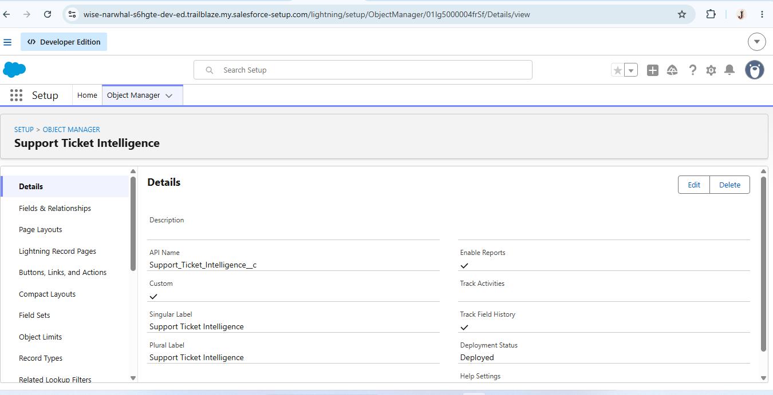

Creating a tab for Support Ticket Intelligence Object

